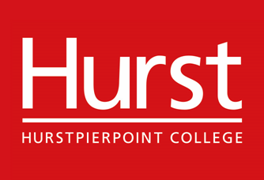

HMC Co-educational Day and Weekly/Flexi Boarding School

Hurstpierpoint College is amongst the most successful independent schools in Sussex. It is co-educational and comprises a Senior School, Preparatory School, and Pre Prep with just over 1,100 pupils in all. Over half the pupils in the Senior School are boarders (weekly or flexi).

The College is committed to safeguarding and promoting the welfare of children and applicants must be willing to undergo child protection screening appropriate to the post, including checks with past employers and the Disclosure and Barring Service (DBS). The successful applicant will be required to complete a Disclosure from the DBS at an enhanced level and we will seek references on short listed candidates and may approach previous employers for information to verify particular experience or qualifications, before interview.

All candidates invited to interview must bring documents confirming any educational and professional qualifications that are necessary or relevant for the post (eg the original or certified copy of certificates, diplomas etc). Where originals or certified copies are not available for the successful candidate, written confirmation of the relevant qualifications must be obtained from the awarding body.

All candidates invited to interview should also bring with them:

- a current driving licence including a photograph
- passport or a full birth certificate
- where appropriate any documentation evidencing a change of name

Please note that originals of the above are necessary. Photocopies or certified copies are not sufficient. Please note that under the school’s data protection policy, any copies of personal documents that are no longer required will be destroyed.

January 2020

